Louise Loves Art

A teacher’s guide created by Marcie Colleen
based on the picture book
by Kelly Light

Published by
Balzer + Bray
An Imprint of HarperCollins Publishers

Kelly Light
Author-Illustrator, Louise Loves Art
Kelly Light lives in New York but grew up down the shore in New Jersey surrounded by giant pink dinosaurs, cotton candy colors, and Skee-Ball sounds. She was schooled on Saturday-morning cartoons and Sunday funny pages. She picked up a pencil, started drawing, and never stopped.

Kelly has illustrated Elvis and the Underdogs and Elvis and the Underdogs: Secrets, Secret Service, and Room Service by Jenny Lee, and the Quirks series by Erin Soderberg. This is her first picture book.

Find her online at www.kellylight.com.

This guide was created by Marcie Colleen, a former teacher with a BA in English Education from Oswego State and a MA in Educational Theater from NYU. In addition to creating curriculum guides for children’s books, Marcie can often be found writing picture books of her own at home in Brooklyn, NYC. Visit her at www.thisismarciecolleen.com.

How to Use This Guide
This classroom guide for Louise Loves Art is designed for students in kindergarten through third grade. It is assumed that teachers will adapt each activity to fit the needs and abilities of their own students.
It offers activities to help teachers integrate Louise Loves Art into English language arts (ELA), mathematics, science, and social studies curricula. Art and drama are used as a teaching tool throughout the guide.
All activities were created in conjunction with relevant content standards in ELA, math, science, social studies, art, and drama.

Guide content copyright © 2015 by Marcie Colleen. Available free of charge for educational use only; may not be published or sold without express written permission.

Table of Contents
English Language Arts (ELA) loves Art
Reading Comprehension 4
Writing Activities 6
“My Imagination on the Outside”
Playing with Words: Found Poetry
Talent Teachers ~ Writing “How to” Instructions 7
Speaking and Listening Activities
Choral Reading
Mime
Drama 8
Vocal Style
Language Activities
My Name as Art ~ Acronyms
Vocab Detectives 9
Math loves Art The Geometry of Art
Geometric Collage
“Shape Up” Field Trip 10
Science loves Art
Up-cycled/Recycled Art
An Artist’s Eye for Nature 11
Social Studies loves Art 13
The Art of Family
A Public Mural 14
Louise Loves Art Books
Louise Loves Louise Nevelson 16
Artists Like Me
We Are All Artists sculpture
Reproducibles
Color Louise’s Glasses 18
Find the Baby Pictures 19
Draw “the cat” 20
English Language Arts loves Art
Reading Comprehension
Before reading Louise Loves Art,
Help students identify the basic parts of a picture book: front cover, back cover, title page, spine, end papers, and jacket flap.
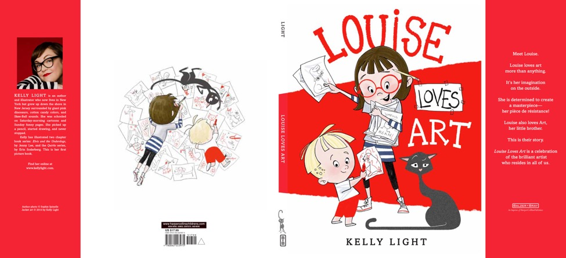
The Front Cover ~
- Kelly Light is the Author-Illustrator of Louise Loves Art. What does an author do? What does an illustrator do? What does it mean if there is an Author-Illustrator?
- Describe the cover illustration in your own words. Look at the characters. Who do you think they are? How do you think they are feeling?
- Stand up and pretend to be the girl character. How does it make you feel? Now pretend to be little boy and/or the cat. How does it make you feel?
- Can you predict what the story might be about?
The Endpapers, Title Page and Copyright Page ~
- The story of Louise Loves Art really starts with the Endpapers and the Title Page illustrations.
- Describe in your own words the beginning Endpaper illustration. Describe in your own words the Title Page illustration.
- Now look at the Copyright Page and the ending Endpaper illustration. Describe in your own words these illustrations. What is different from the beginning Endpaper and Title Page illustrations?
- Do these illustrations help you predict further what the book will be about?
Now read or listen to the book.
Help students summarize in their own words what the book was about.
- What is Louise doing in the beginning of the book? What is Art doing? Describe Louise. Describe Art.
- What does Art do to Louise’s drawings? Why do you think he does this?
- Does Louise notice right away that Art has drawn on her artwork?
- According to Louise, what do artists need to focus on?
- What does the word “masterpiece” mean? Can you guess from the context? Look up the word in a dictionary and then describe its meaning in your own words.
- Which drawing does Louise call her “masterpiece”?
- There are drawings of Louise’s all over the house. Which are some of your favorites?
- Where does Louise hang her best art?
- How does Louise react when Art cuts up her drawing? How does Art react? Why do you think Art cut the drawing?
- Where does Louise hang Art’s “masterpiece”? Why do you think she hangs it where she does?
Look closely at the following spreads:
The Title Page spread
- Louise’s art is everywhere. Can you find
  - A car driving giraffe?
  - Two 3-eyed aliens?
  - A fiddle-playing cow?
  - A tap-dancing octopus?
  - A koala bear?
  - An owl?
The Gallery du Fridge: before and after
- Look closely at the items on the Gallery du Fridge before Art’s masterpiece is added. What do you see? How many items are Louise’s? How many are Art’s?

- Look closely at the items on the Gallery du Fridge after Art’s masterpiece is added. What changes do you see?

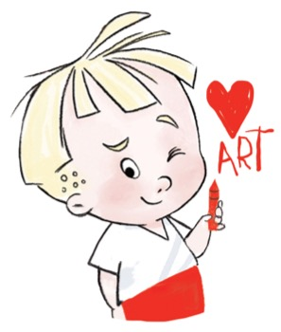
- How does the Gallery du Fridge reflect Louise’s attitude change at the end of the story? What brought about this change?
Writing Activities
“My Imagination on the Outside”
Louise declares art to be her “imagination on the outside”.
Take a close look at some of Louise’s drawings. In the world of Louise’s imagination giraffes can drive cars, elephants jump around on pogo sticks and girls eat ice cream cones that are almost as big as they are!
What are some fun things in the world of your imagination? Let’s take a trip into the world of YOUR own imagination!
- Write a creative story about what it would be like to show a friend around this world.
- How would you get there?
- What would you do?
- What would you see?
- Then, illustrate this world with an imaginative drawing of your own.
Optional: Create the story together as a class.
Playing with Words: Found Poetry
Visual artists often use “found objects” in their artwork. They collect interesting items during the day that they then incorporate into a sculpture, painting, collage, etc.
A “found poem” is essentially doing the same thing with words that students collect throughout the day.
Use these fun steps to guide students through the creation of their own “found poems”.
- Collect words. Students will keep a notebook or an index card with them all day. When they hear or see a word that is unusual, beautiful, funny, or otherwise interesting to them, write it down. Look for words in magazines, newspapers, street signs, banners, junk mail, posters, cereal boxes, and of course the library! And open ears to what people are saying, too. Older students can be assigned a certain number of nouns, verbs, adjectives, etc to find.
- Search Louise Loves Art. Print out a copy of the text from Louise Loves Art. Use scissors to cut up the text of the poem into phrases or even single words.
- Create poetry! Mix up the “found” words and the words from Louise Loves Art and create a new poem or story.
- Plan a poetry slam. Celebrate creativity and have students read their poems for their classmates and families.
Talent Teachers ~ Writing “How to” Instructions
Art looks up to Louise and wants to be an artist, too. At the end of the book we see Louise teaching Art how to draw a cat.
What is something you love to do that you want to share with your friends?
Do you know how to make the best grilled cheese? Or how to play a certain game? Or how to make a certain craft?
- Create a detailed list of steps needed.
- Add photographs or drawings where you can to best explain.
- Be prepared to share your talent with the class through an oral presentation.
Speaking and Listening Activities
Picture books are written to be read aloud. Here are some other ways to bring Louise Loves Art to life in the classroom and also have fun with speaking and listening skills!
Choral Reading
Half of the class can take on the role of Louise, the other half can be Art.
Create a script.
Read the script aloud together.
Emphasize memorization of the students' parts as well as good vocal expression.
Mime
While the teacher reads the book aloud, the students can act out the story.
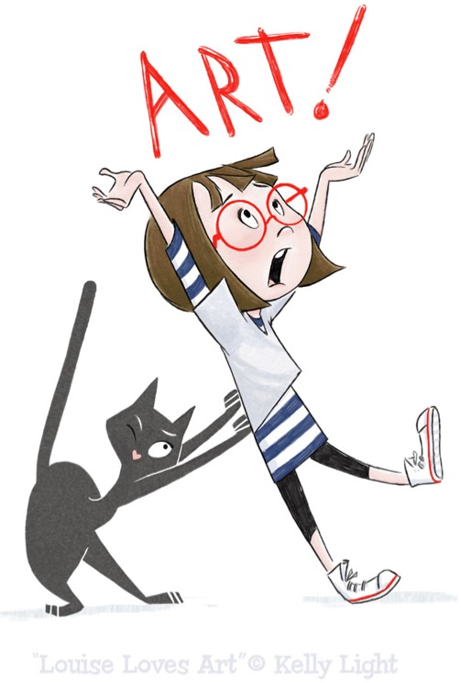
Emphasize body motion and facial expressions, as well as listening skills.
Drama
Ask the students to think of all of Louise’s drawings.
Have the students pose as one of the drawings in front of the class.
The class can then guess which drawing they are acting out.
Or
Create a TV commercial to encourage people to read Louise Loves Art.
Vocal Style
In small groups, act out Louise Loves Art as:
- an opera
- a western
- a “breaking news” story,
- a thriller, etc.
The rest of the class will then guess what “style” is being presented.
Language Activities
My Name as Art ~ Acronyms
Although Art’s name literally is art, your name can be art, too!
Have the students create acronyms for their own names.
The students should come up with a word for each letter in their names.
Choose words that best describe them or things that they like to do.
Then have students create a poster with their name on it and all of the words that make up their acronyms.
Additionally, they can create a collage of their words and pictures that represent those words.
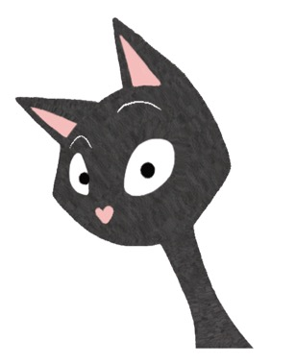
Vocab Detectives
Louise Loves Art has some new and challenging vocabulary.
Words like “feline” and “piece de resistance” may be unknown to some young readers.
Re-read Louise Loves Art aloud and ask students to listen carefully for words they do not know.
- As soon as they come across an unknown word they should raise their hand.
- Repeat the phrase using the unknown word. What might it mean, based on context?
- Look up the word in the dictionary. (Depending on the level of your students, a student volunteer can do this or the teacher can.) Read the definition.
- Come up with a way to remember what the word means. Using Total Physical Response, students can create an action that symbolizes the word and helps them remember it.
- Re-read the story and when you come to a vocabulary word, have the students fill in the meaning in how they choose to remember it.
Create a list of the vocabulary words and hang it on the wall. Revisit it again and again
Math loves Art
The Geometry of Art
Drawings are simple shapes put together to create an object.
Have students find circles, squares, ovals, rectangles, and triangles within the illustrations of Louise Loves Art.
How many circles can they find? Or rectangles?
Geometric Collage
Provide students with various pieces of construction paper shapes: circles, squares, rectangles, ovals, hearts, triangles, etc.
Challenge each student to use the shapes to create a picture. For example, maybe a rectangle turns into a building with a triangle pine tree nearby and a circle sun in the sky.
Try to move students towards creating objects instead of abstract works.
Encourage adding lines with markers to enhance objects and add detail.
“Shape Up” Field Trip
Divide the students into 4 teams: Circles, Squares, Triangles, and Rectangles.
Lead them on a field trip to the library, playground, or through the school hallways.
As a group, each team must look for their assigned shape in various objects seen on the trip.
If possible, each team should be given a digital camera to record their findings.
As they find an object, take a picture of it.
Another student should take notes and jot down what object they found and where they found it.
Every student in the group should have the opportunity to take at least one picture and to take at least one set of notes.
At the end of the field trip, students should return back to the classroom and try to draw or create a photo collage of all of the items that their team found for display in the classroom.
Optional: For further technological experience, teams can use the computer and a scanner to create a multimedia presentation of their findings to present to the class.
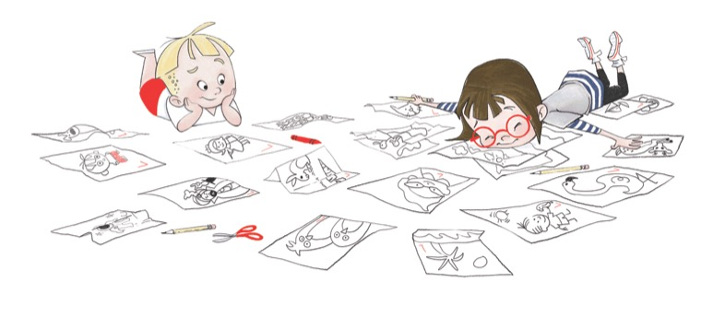
Science loves Art
Up-cycled/Recycled Art
One way to show a love for Earth is to recycle used items instead of sending items to landfills.
If your class is unaware of the benefits of recycling, a lesson can be incorporated before engaging in this art project. Your librarian should be able to point you to several books on the recycling and reusing.
Ask students whether they and their families recycle.
What kind of items do they recycle?
List some of the items that are made from these objects once they are recycled.
soft playground flooring and running tracks from tires;
paper bags, confetti, and toilet paper from paper;
and sleeping bags and fleece from plastic drink bottles.
Can you imagine wearing a pair of sandals made from an old car tire?
These are quite common in Africa and are called "thousand milers" because of the long distance the rubber carries not only the car, but also the sandal wearer.
Ask students to bring items from home that they find interesting and unique and do not want anymore. They can ask their parents to help them look in the garage, attic, or drawers. The recycling bin is also a great place to look!
Working in groups, students must re-purpose the objects into a useful invention of their own, such as the “thousand milers”.
Extra bonus points if more than one recycled object is combined to make one invention.
Provide the class with glue, cardboard, string, and other art supplies.
Demonstrate the inventions for the class and display them in the school library along with information about recycling.
Check out www.recyclart.org for ideas and inspiration.
An Artist’s Eye for Nature
Nature in itself is beautiful art.
Go on a nature walk around the school or ask students to take a nature walk in their neighborhoods and gather pieces of natural art that they find. Acorns, leaves, flowers, petals, rocks, etc. Be sure to point to not pick or harm any growing/living thing to gather items.

Activity #1
Once items have been gathered, take time to look at each item closely.
What are the shapes that make up this piece of nature?
What are the different colors?
Are there small details that you didn’t notice before?
Show the class examples of Georgia O'Keeffe's flower paintings. As the children look closely, tell them about her life and her work.
Two great books on O’Keeffe are Through Georgia’s Eyes by Rachel Victoria Rodriguez and Julie Paschkis (Holt 2006) and My Name is Georgia: A Portrait of Jeanette Winter by Jeanette Winter (HMH 2003).
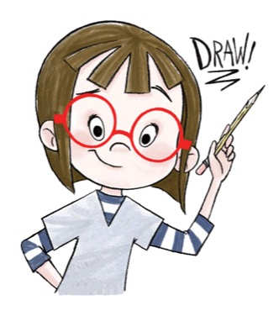
Explain that making something larger than life catches our attention and causes us to look more closely.
- Each student should choose one item to paint.
- Using pencils, have the children draw the basic outline, or outer edge, of their item on paper. Encourage them to draw the outline so big that it touches or even goes off the edge of the paper.
- Have students paint their item, closely observing the variety of colors, textures and details.
- When the paintings are completed, the students should paint the backgrounds.
Display the paintings in a classroom gallery.
Activity #2
Drying and pressing leaves and flowers can be done by placing the items under a large heavy book, or you can get scientific about it and use a fun chemical reaction to create 3-dimensional artwork.
Materials needed:
Sand
Household Laundry Borax
Medium-sized cardboard box with cover removed
Directions:
- Make a mixture of 3 parts borax and 1 parts sand.
- Dump this mixture into the cardboard box and spread evenly.
- Place each flower or leave face down into the mixture, making sure that it is fully covered. Stems can be left uncovered and upright.
- Store in a dark, dry place for 2-3 weeks.
The dried flowers and leaves can then be used to create a piece of art. Apply the flowers or leaves to a piece of paper, canvas or poster board with simple white glue.
What is it about the sand and borax that dries out the flower and leaf? Research the reason online!
Social Studies loves Art
The Art of Family
Louise Loves Art is a book about sibling relationships.
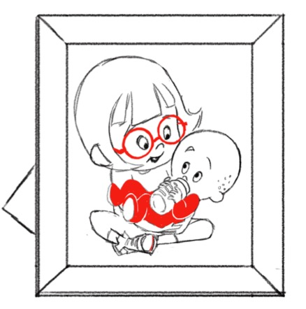
Even though Louise is consumed with her artwork, there is evidence throughout the illustrations of Louise’s relationship with her younger brother. Can you find some? (note: Louise’s drawings of Art and the photo of the two of them on the wall wearing berets)
At the same time, Art looks up to Louise and wants to be just like her. There is lots of evidence to show this in the illustrations, as well.
In the end we see the two coming together through art.
If Louise was asked to list 5 things she admires about Art, what do you think she would say? What would Art say about Louise?
Ask students to think of someone they look up to. It can be a family member or a friend or someone they know of in the community. What are 5 things that they admire about that person?

The Project:
- Have each student lay down on a large piece of paper while someone traces their body with a pencil.
- Once the student has the silhouette of their body, write the 5 things about the person they chose inside the outline.
- Then decorate the silhouette to further depict the relationship between the student and their person they admire. Photos can be added to create a collage.
- Finished silhouettes can be displayed with the title “Our Families and Friends are a Part of Us”.
A Public Mural
Throughout history, art has been used to transform public spaces into places of beauty and reflection. Most importantly, these pieces of public art are used to bring about tighter community.

Look up examples of public art on the Internet: examples in subways, under bridges and in parks. Be sure to find examples of traditional murals painted on walls, but also sculptures and knit-bombing.

How can art be used to foster community?

- Bring people together to create it
- Reflect all people in the community in the artwork
- Create a space that people will want to visit and hang out in

Make your own piece of public art for your school community!

- Choose a space within the school that could use some brightening or some inspiration.
- Brainstorm a mural or other piece of temporary art called “My Imagination on the Outside” that can be created in this space.
- Brainstorm how this mural can build community.
- Involve as many people as possible in the creation.

Louise Loves Art Books
There are thousands of museums worldwide to celebrate art. But who are the people behind the art? What led them to become artists? What makes them tick?
The following list of books is a great starting point to read individually or as a class.
Noisy Paint Box: The Colors and Sounds of Kandinsky’s Abstract Art by Barb Rosenstock (Knopf, 2014)
A Splash of Red: The Life and Art of Horace Pippin by Jen Bryant, illus. Melissa Sweet (Knopf, 2013)
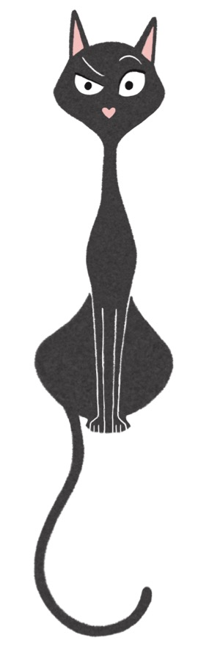
In Mary’s Garden by Tina Kugler and Carson Kugler (HMH Books for Young Readers, 2015)
Dream Something Big: The Story of Watts Towers by Dianna Hutts Aston, illus. Susan L. Roth (Dial, 2011)
Draw! by Raul Colon (Paul Wiseman Books, 2014)
Emily’s Blue Period by Cathleen Daly, illustrated by Lisa Brown (Roaring Brook Press, 2014)
Viva Frida by Yuyi Morales (Roaring Brook Press, 2014)
Frida by Jonah Winter, illus. Ana Juan (Arthur A. Levine Books, 2002)
Diego by Jonah Winter, illus. Jeanette Winter (Dragonfly Books, 1994)
The Iridescence of Birds: A Book about Henri Matisse by Patricia MacLachlan, illus. Hadley Hooper (Roaring Brook, 2014)
Magic Trash: A Story of Tyree Guyton and His Art by J.H. Shapiro, illus. Manessa Brantley-Newton (Charlesbridge, 2011)
My Hands Sing the Blues: Romare Bearden’s Childhood Journey by Jeanne Walker Harvey, illus. Elizabeth Zunon (Two Lions, 2011)
George Bellows: Painter with a Punch by Robert Burleigh (Abrams, 2012)
Fabulous! A Portrait of Andy Warhol by Bonnie Christensen (Holt, 2011)
Just Behave, Pablo Picasso by Jonah Winter, illus. Kevin Hawkes (Arthur A. Levine, 2012)
It Jes’ Happened When Bill Traylor Started to Draw by Don Tate, illus. H. Gregory Christie (Lee & Low, 2012)
Action Jackson by Jan Greenberg, illus. Robert Andrew Parker (Square Fish, 2007)
The Fantastic Jungles of Henri Rousseau by Michelle Markel, illus. Amanda Hall (Eerdmans Books for Young Readers, 2012)
Louise Loves Louise Nevelson
When Kelly Light was 8 years old, she walked into a museum and for the first time encountered the work of a female artist. As she looked upon the wooden “found objects” sculpture, Kelly noticed the name on the plaque beside it—Louise Nevelson. “A girl!” she gasped. It was at that moment that Kelly’s dream of what she wanted to be when she grew up became fully realized. She could be an artist, too.
- Conduct an Internet search and share some images of the work of Louise Nevelson with the class.
- Would you know that this piece was created by a girl? Why or why not?
When it was time to choose a name for her picture book protagonist, Kelly chose Louise after Louise Nevelson who first “taught” Kelly that girls can make art, too.
- Highlight some other female artists such as Grandma Moses, Frida Kahlo, Georgia O’Keefe, or Mary Blair for the class.
Artists Like Me
It is important that students see faces that mirror their own in all areas of life.
For Kelly Light, that meant learning about a female artist. Maybe for another student it might mean knowing artists can be Mexican like Frida Kahlo and Diego Rivera, African American like Horace Pippin, or disabled like comic artist Larime Taylor.
- Guide students through researching other artists like them in either gender or ethnicity.
- Create a brief oral report on:
  - the artists’ greatest art contribution or what they are known for
  - What influenced the artist?
  - What was the main subject matter of the artist’s work (landscapes, still life, portraits, etc.)?
We are All Artists sculpture
Then, as a class, create a “found object” sculpture in the style of Louise Nevelson.
- Each student should bring to class an object that will represent them.
- Paint the piece completely black.

Louise Nevelson said, “I fell in love with black; it contained all color. It wasn't a negation of color... Black is the most aristocratic color of all... You can be quiet, and it contains the whole thing.” Discuss what this might mean.

- Connect the piece to all of the other students’ pieces to create a sculpture.
- Name the sculpture we are all artists.

